AML DASHBOARD
Using Microsoft Power BI
Project Report

Submitted By
Name: Theeshmitha.S
Roll No.: E25FA068
Course: B.Com FinTech and AI

Power BI Report
AML Transaction & Fraud Analysis Dashboard
1. Introduction
Anti-Money Laundering (AML) monitoring helps banks and financial institutions identify unusual transactions and possible fraudulent activity. Since financial systems process a large volume of transactions, visual dashboards help analysts review patterns, compare fraud and non-fraud records, and prioritise suspicious activity.
This report explains the AML Transaction & Fraud Analysis dashboard created in Microsoft Power BI. It describes the key performance indicators and the five visual analysis areas visible in the supplied dashboard screenshot: overall transaction volume, fraudulent transaction volume, fraud-status distribution, alerts by type, and transaction value by fraud status.
2. Objectives
- To summarise transaction activity using KPI cards.
- To compare the number and proportion of fraudulent and non-fraudulent transactions.
- To observe transaction volume and fraudulent transaction volume across timestamps.
- To compare alert counts by alert type.
- To compare transaction value for fraud and non-fraud groups.
- To present the results in a clear dashboard for easier monitoring and decision-making.
3. Dataset Description
The supplied dashboard displays transaction, account, and alert information. The screenshot shows the fields and measures used in the visuals, but it does not expose the complete underlying dataset or all column definitions. The following table describes the information that can be identified from the chart.
Data area | Visible fields / measure | Use in the dashboard
Transactions | TIMESTAMP; IS_FRAUD; transaction amount | Shows transaction volume over time, fraud status distribution and transaction value.
Accounts | Total Account KPI | Summarises the number of accounts shown by the KPI card.
Alerts | ALERT_TYPE; alert count | Compares the counts for CYCLE and FAN_IN alert categories.
KPI measures | Total Transaction; Total Transaction Amount; Fraudulent Transactions | Provides a quick summary of the dataset and fraud-related activity.
4. Tools Used
- Microsoft Power BI Desktop for importing data, preparing the model and building visualisations.
- Power BI visual types including line charts, a donut chart, a bar chart, a column chart and KPI cards.
- Data Analysis Expressions (DAX) may be used to define measures; the screenshot alone does not show the exact formulas.
- A light dashboard theme with blue-grey chart elements for readability.
5. Dashboard Overview
The dashboard combines KPI cards with charts so that the viewer can examine both the overall scale of activity and specific fraud indicators. The KPI cards show approximately 1M total transactions, a total transaction amount beginning with $153.47950620… as displayed, 10K accounts and 2K fraudulent transactions. The charts provide more detail about transaction patterns, fraud status, alert types and transaction values.
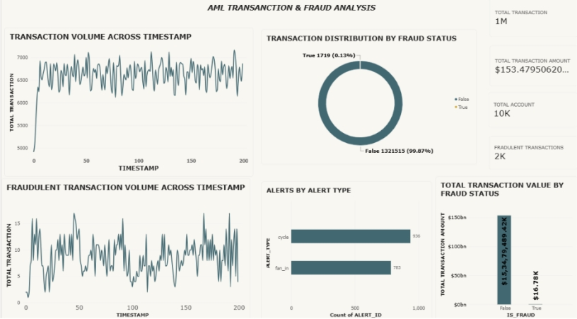
6. Key Performance Indicators (KPI Cards)
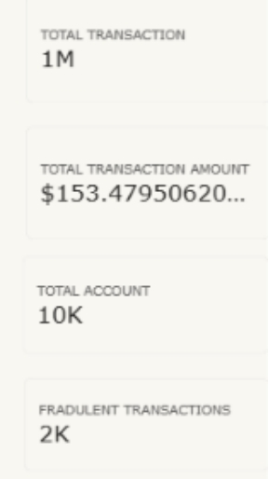
KPI | Displayed value | Explanation
Total Transaction | 1M | The card abbreviates the total transaction count to approximately one million.
Total Transaction Amount | $153.47950620… | The card displays the combined transaction amount; the full value is truncated in the screenshot.
Total Account | 10K | The card abbreviates the account count to approximately ten thousand.
Fraudulent Transactions | 2K | The card rounds the number of records marked as fraudulent to approximately two thousand.
Purpose: KPI cards provide a quick summary of the scale of transactions, accounts and fraud-related activity without requiring the viewer to inspect each chart individually.
7. Visualizations Used
- Transaction Volume Across Timestamp
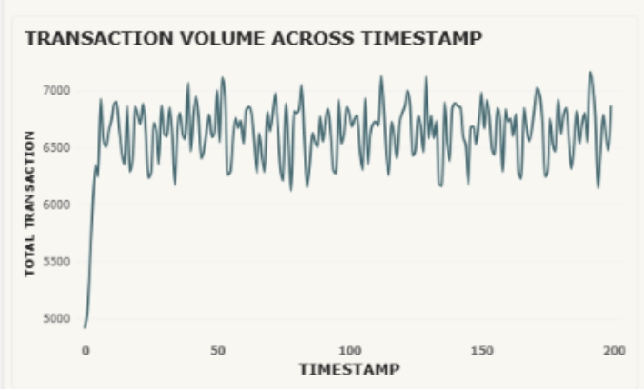
A line chart displays total transaction volume across timestamps, with the horizontal axis running from approximately 0 to 200. The line starts near 4,900, rises sharply at the beginning, and then fluctuates mostly between about 6,200 and 7,100 transactions. The repeated peaks and dips show changes in activity, while the overall range remains relatively stable after the initial rise.
- Tracks transaction activity over time.
- Helps identify sudden increases or decreases in volume.
- Provides a baseline against which unusual activity can be reviewed.
- Fraudulent Transaction Volume Across Timestamp
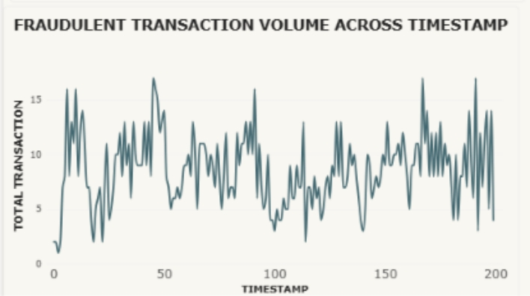
The line chart shows fraudulent transaction counts at each timestamp. Values fluctuate frequently, ranging approximately from 1 to 17 transactions in the displayed period. The irregular pattern suggests that fraud-related records are not evenly distributed over time. Peaks can be used as points for further review, but the chart alone does not establish the reason for each increase.
- Highlights timestamps with relatively higher fraud counts.
- Allows comparison with the overall transaction trend.
- Can help analysts decide where additional investigation may be useful.
- Transaction Distribution by Fraud Status
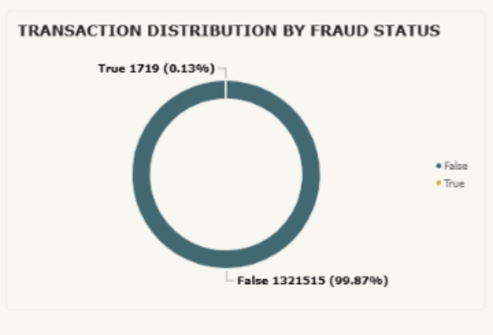
The donut chart compares the values False and True in the IS_FRAUD field. It displays 1,321,515 records as False (99.87%) and 1,719 records as True (0.13%). This shows that the records marked True make up a very small share of the displayed transaction population. The KPI card rounds the fraud count to 2K, while the donut chart shows the more specific count.
- Shows the proportion of records in each fraud-status category.
- Makes the imbalance between False and True easy to see.
- Reminds the viewer that a small fraud share may still require careful monitoring.
- Alerts by Alert Type
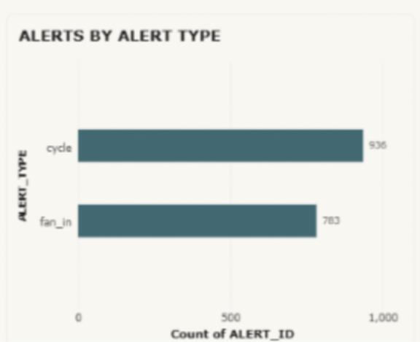
The horizontal bar chart compares two alert categories. CYCLE has 936 alerts and FAN_IN has 783 alerts. CYCLE is therefore the more frequent alert type in this dashboard. In transaction monitoring, a cycle pattern can refer to funds moving through a sequence of accounts and returning to an earlier point, while fan-in can refer to funds from multiple accounts converging into one account. These labels indicate patterns for review; an alert by itself is not proof of fraud.
- Compares the number of alerts in each category.
- Shows which alert type appears more frequently.
- Can support prioritisation of alert review and investigation.
- Total Transaction Value by Fraud Status
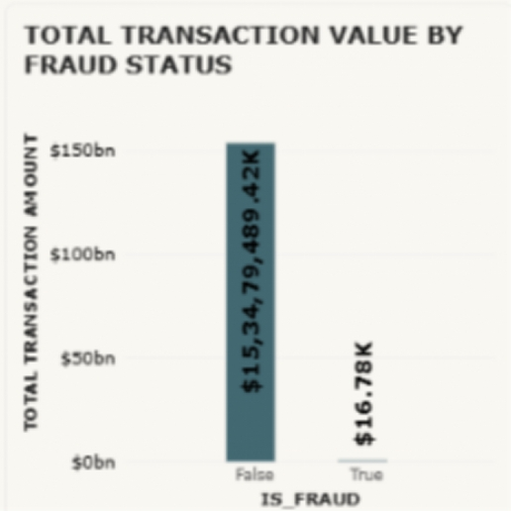
The column chart compares total transaction value for records marked False and True. The False column is much higher than the True column. The value labels in the screenshot appear as approximately $153,479,489.42K for False and $16.78K for True; the unusual display scaling/formatting should be checked against the underlying Power BI measure before these labels are used as exact monetary totals. The reference dashboard describes the False total as about $153.48 billion. The screenshot shows a dollar symbol, so this report retains the displayed currency notation rather than converting it to another currency.
- Compares the financial value across fraud-status groups.
- Shows that the displayed total value for False is substantially larger.
- Encourages checking the underlying measure and formatting before interpreting exact amounts.
8. Key Insights
- The KPI cards report approximately 1M transactions and 10K accounts.
- The Total Transaction Amount card begins with $153.47950620…, but the complete number is not visible in the screenshot.
- The fraud-status donut shows 1,719 True records (0.13%) and 1,321,515 False records (99.87%).
- The Fraudulent Transactions KPI rounds the fraud count to 2K, which is consistent with the more precise donut-chart count when rounded.
- Overall transaction volume rises at the beginning and then fluctuates mostly within a range of about 6,200 to 7,100.
- Fraudulent transaction volume is more irregular, with repeated peaks and dips across the displayed timestamps.
- CYCLE alerts (936) are more frequent than FAN_IN alerts (783).
- The transaction-value chart shows a very large difference between the False and True groups; the displayed value formatting should be verified in Power BI before reporting an exact total.
9. Recommendations
- Review timestamps where fraudulent transaction counts show noticeable peaks.
- Investigate CYCLE alerts first by volume, while still reviewing FAN_IN alerts according to risk and priority.
- Validate the DAX measure and display units for Total Transaction Amount so the card and column chart present a consistent, readable value.
- Confirm the currency and number format used in the source data before sharing monetary results.
- Treat alerts as indicators for investigation rather than as confirmed fraud without additional evidence.
10. Conclusion
The AML Transaction & Fraud Analysis dashboard presents a useful visual summary of transaction activity and fraud-related indicators. KPI cards communicate the overall scale, line charts show changes over time, the donut chart compares fraud status, the bar chart compares alert types, and the column chart compares transaction value. The dashboard indicates that True records represent a small proportion of transactions and that CYCLE alerts are more frequent than FAN_IN alerts. Before final reporting, the transaction-value measure and its currency/display format should be checked so that monetary figures are interpreted correctly.
Appendix: Dashboard Screenshot

